Title:Clustering of neuronal K⁺-Cl⁻ cotransporter in the lipid rafts by tyrosine phosphorylation

Authors: Miho Watanabe, Hiroaki Wake, Junichi Nabekura

Department/Division, University/Institute: Division of Homeostatic Development, National Institute for Physiological Sciences, Okazaki, 444-8585, Japan,

Abstract:
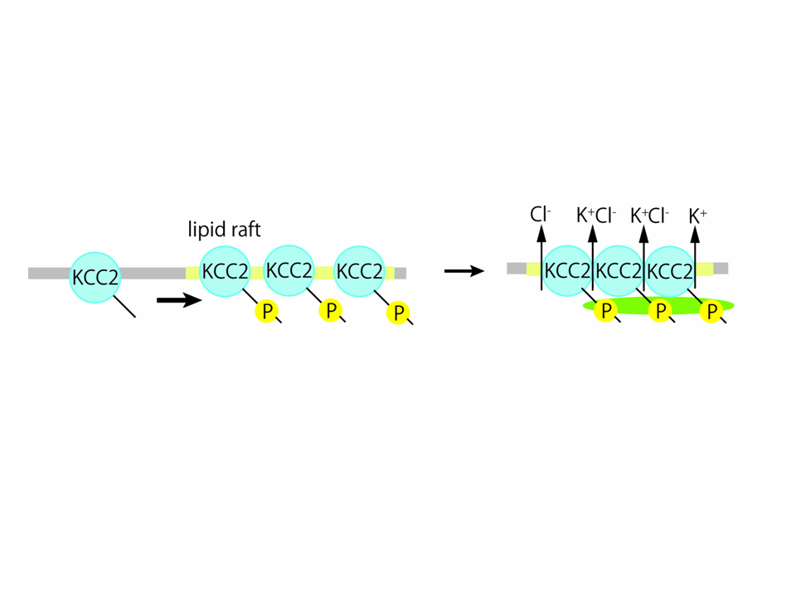
. KCC2 is a principal molecule to exclude Cl⁻ out of the neurons and contributes to the maintenance of low [Cl⁻]_{i}. The mechanisms regulating KCC2 function have important implications for understanding the plasticity of GABA and glycine-driven inhibitory transmission. In addition to an increasing the evidences of the long term regulation of KCC2 protein in development and damaged neurons, much attention has been recently paid to a rapid and dynamic alteration of KCC2 function. However, less is known regarding the regulation of KCC2 molecule directly linked to appear its function. KCC2 contains one consensus of a tyrosine protein kinase phosphorylation site located at the long carboxy terminal. Genistein, tyrosine kinase inhibitor, shifted E_{GABA} to more depolarized values and induced translocation of KCC2 from punctate stainings to more uniform distribution in the hippocampal neurons. Mutation of the tyrosine kinase amino acid residue (Y1087D) also reduced KCC2 activity and abolished its punctate distribution along the membrane, indicated that phosphorylated KCC2 form cluster in restricted membrane domain. Sodium vanadate, a tyrosine phosphatase inhibitor, increased the proportion of KCC2 associated with lipid rafts, suggesting that phosphorylation of KCC2 facilitated the interaction of this molecule with lipid rafts. Furthermore, loss of tyrosine phosphorylation reduced oligomerization of KCC2, indicating that tyrosine phosphorylation is required for KCC2 oligomerization. Deletion of 28 amino acid residue in carboxy terminal of KCC2 did not show clustering and oligomer. These results suggest that KCC2 forms cluster by tyrosine phosphorylation via carboxy terminal, thereby extrude Cl⁻ efficiently to maintain local Cl⁻ low.

